Step 1: <https://www.postman.com/downloads/>

Step 2: click on download

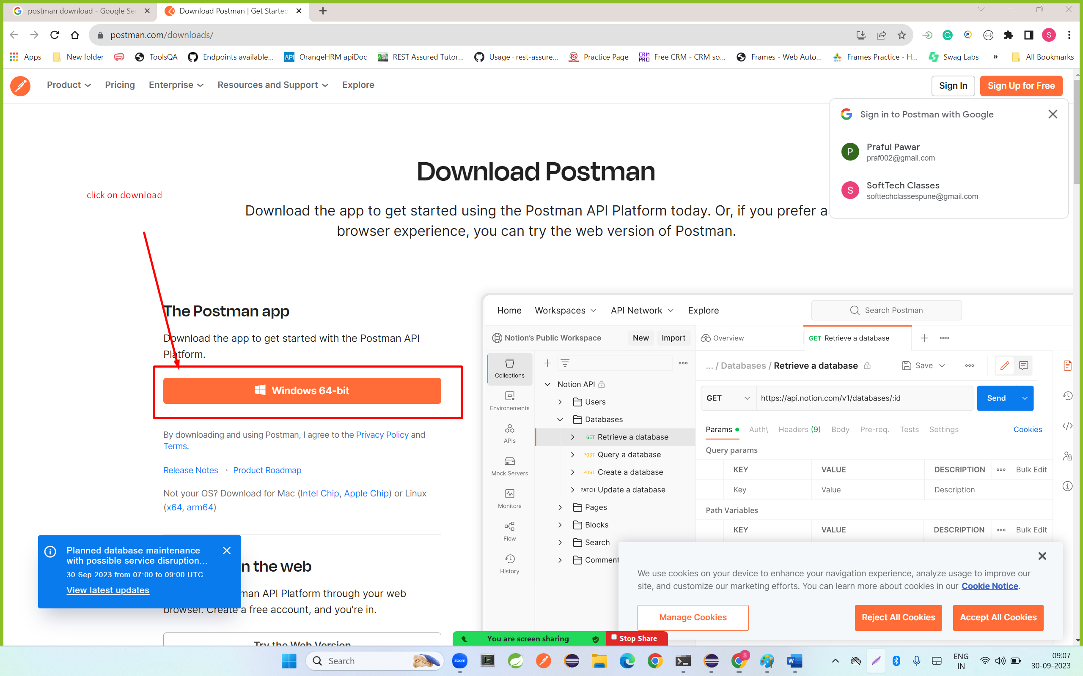

**Step 3download visual studio code**

[**https://code.visualstudio.com/download**](https://code.visualstudio.com/download)

**step 4: click on download**

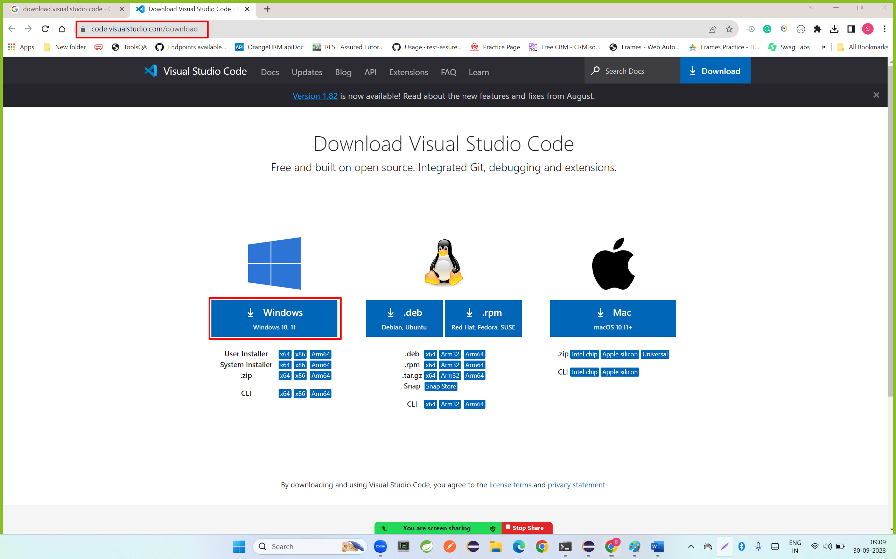

**Step 5: click on I accept and click on next**

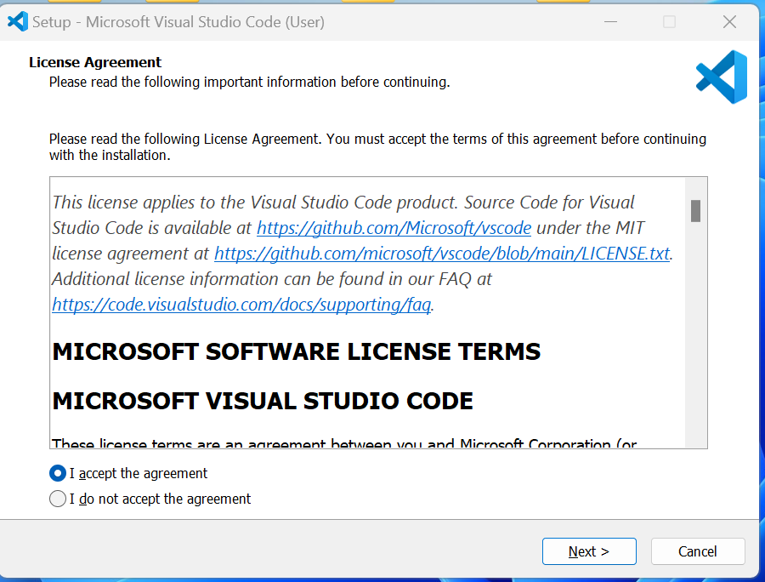

**Step 6: select all checkbox and click on next button**

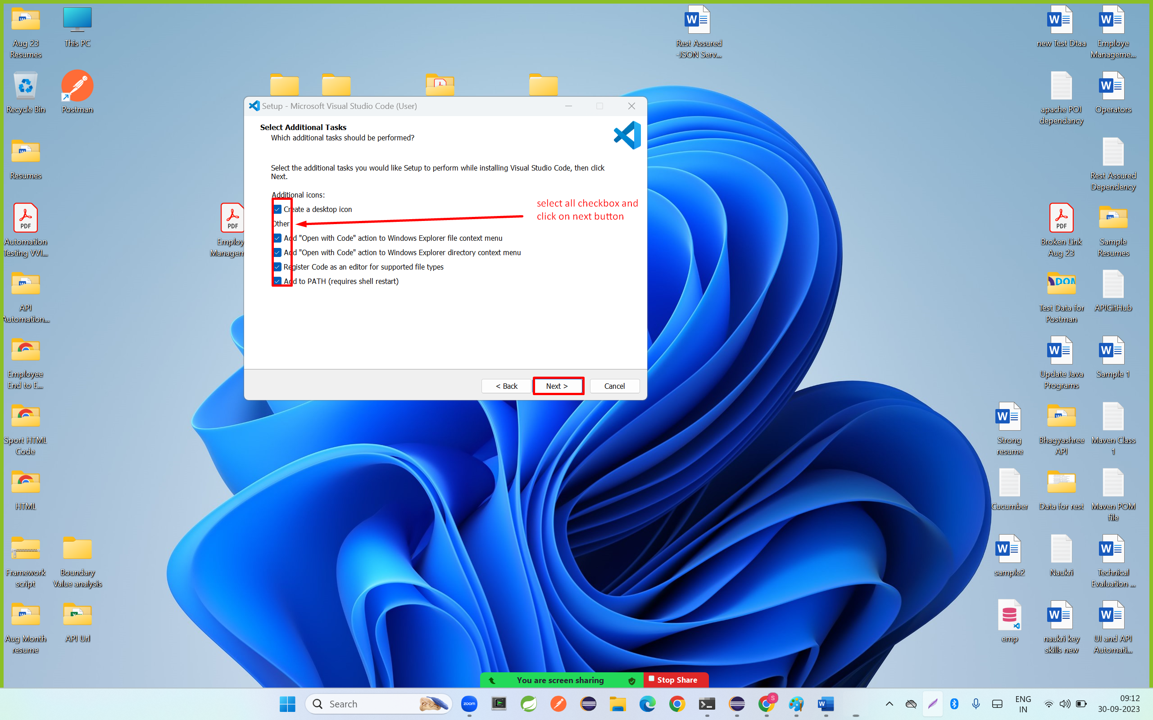

**Step 7 : click on install button**

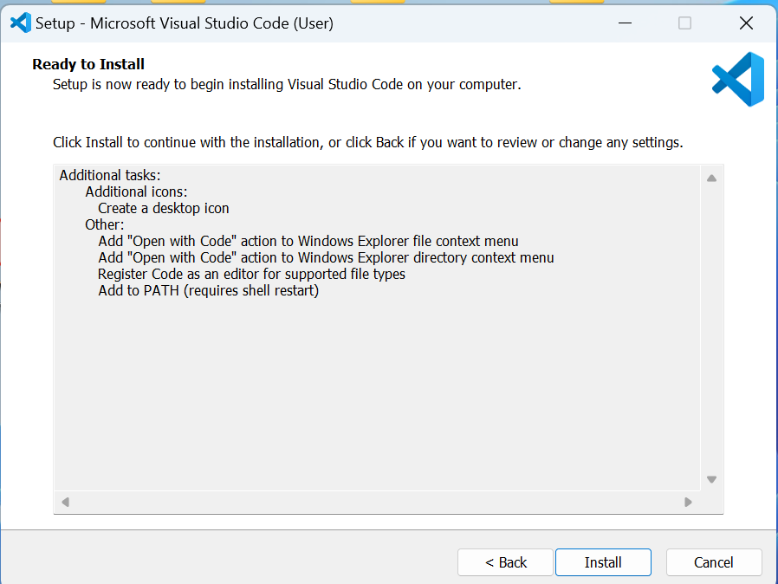

**Step 8: click on finish button**

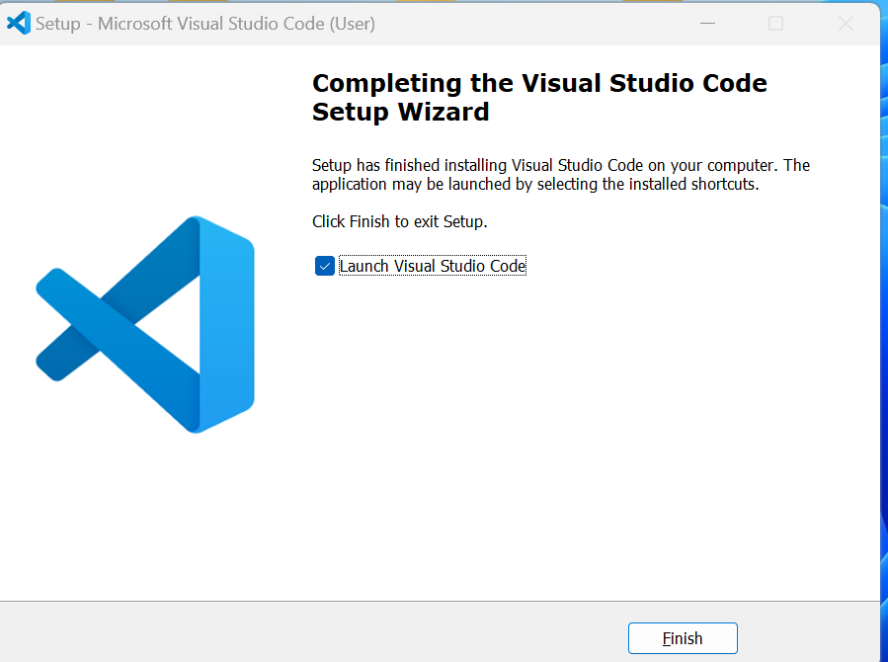

**Download Node JS**

Step 1: download the node JS

[**https://nodejs.org/en/download**](https://nodejs.org/en/download)

**step 2: click on download button**

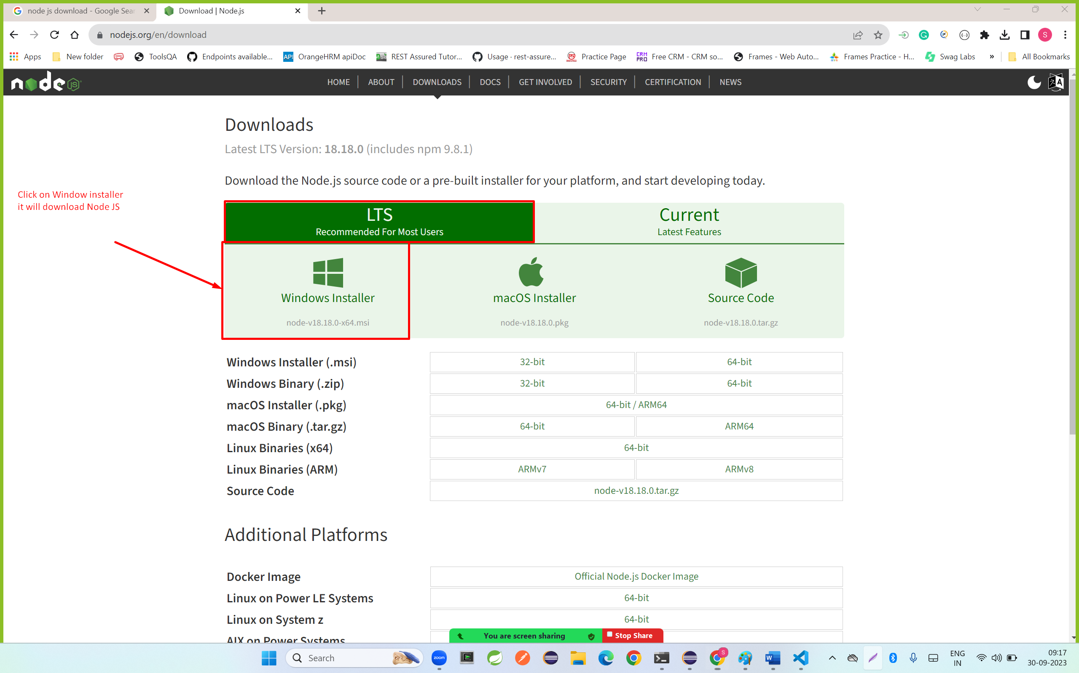

**Step 3: click on download file and click on next button**

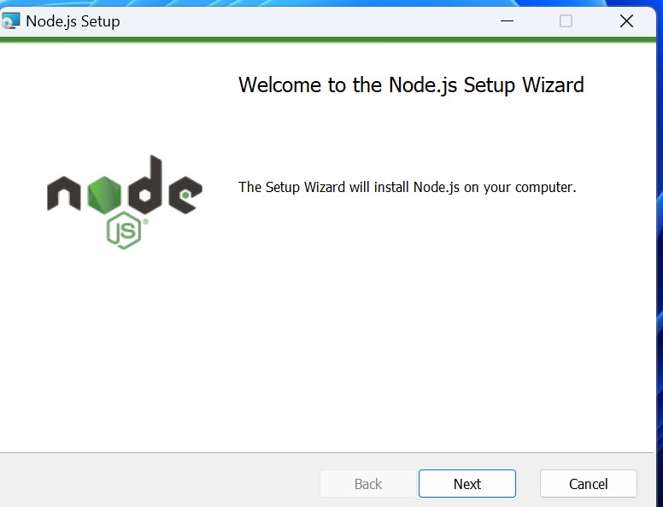

**Step 4: click on I accept and click on next button**

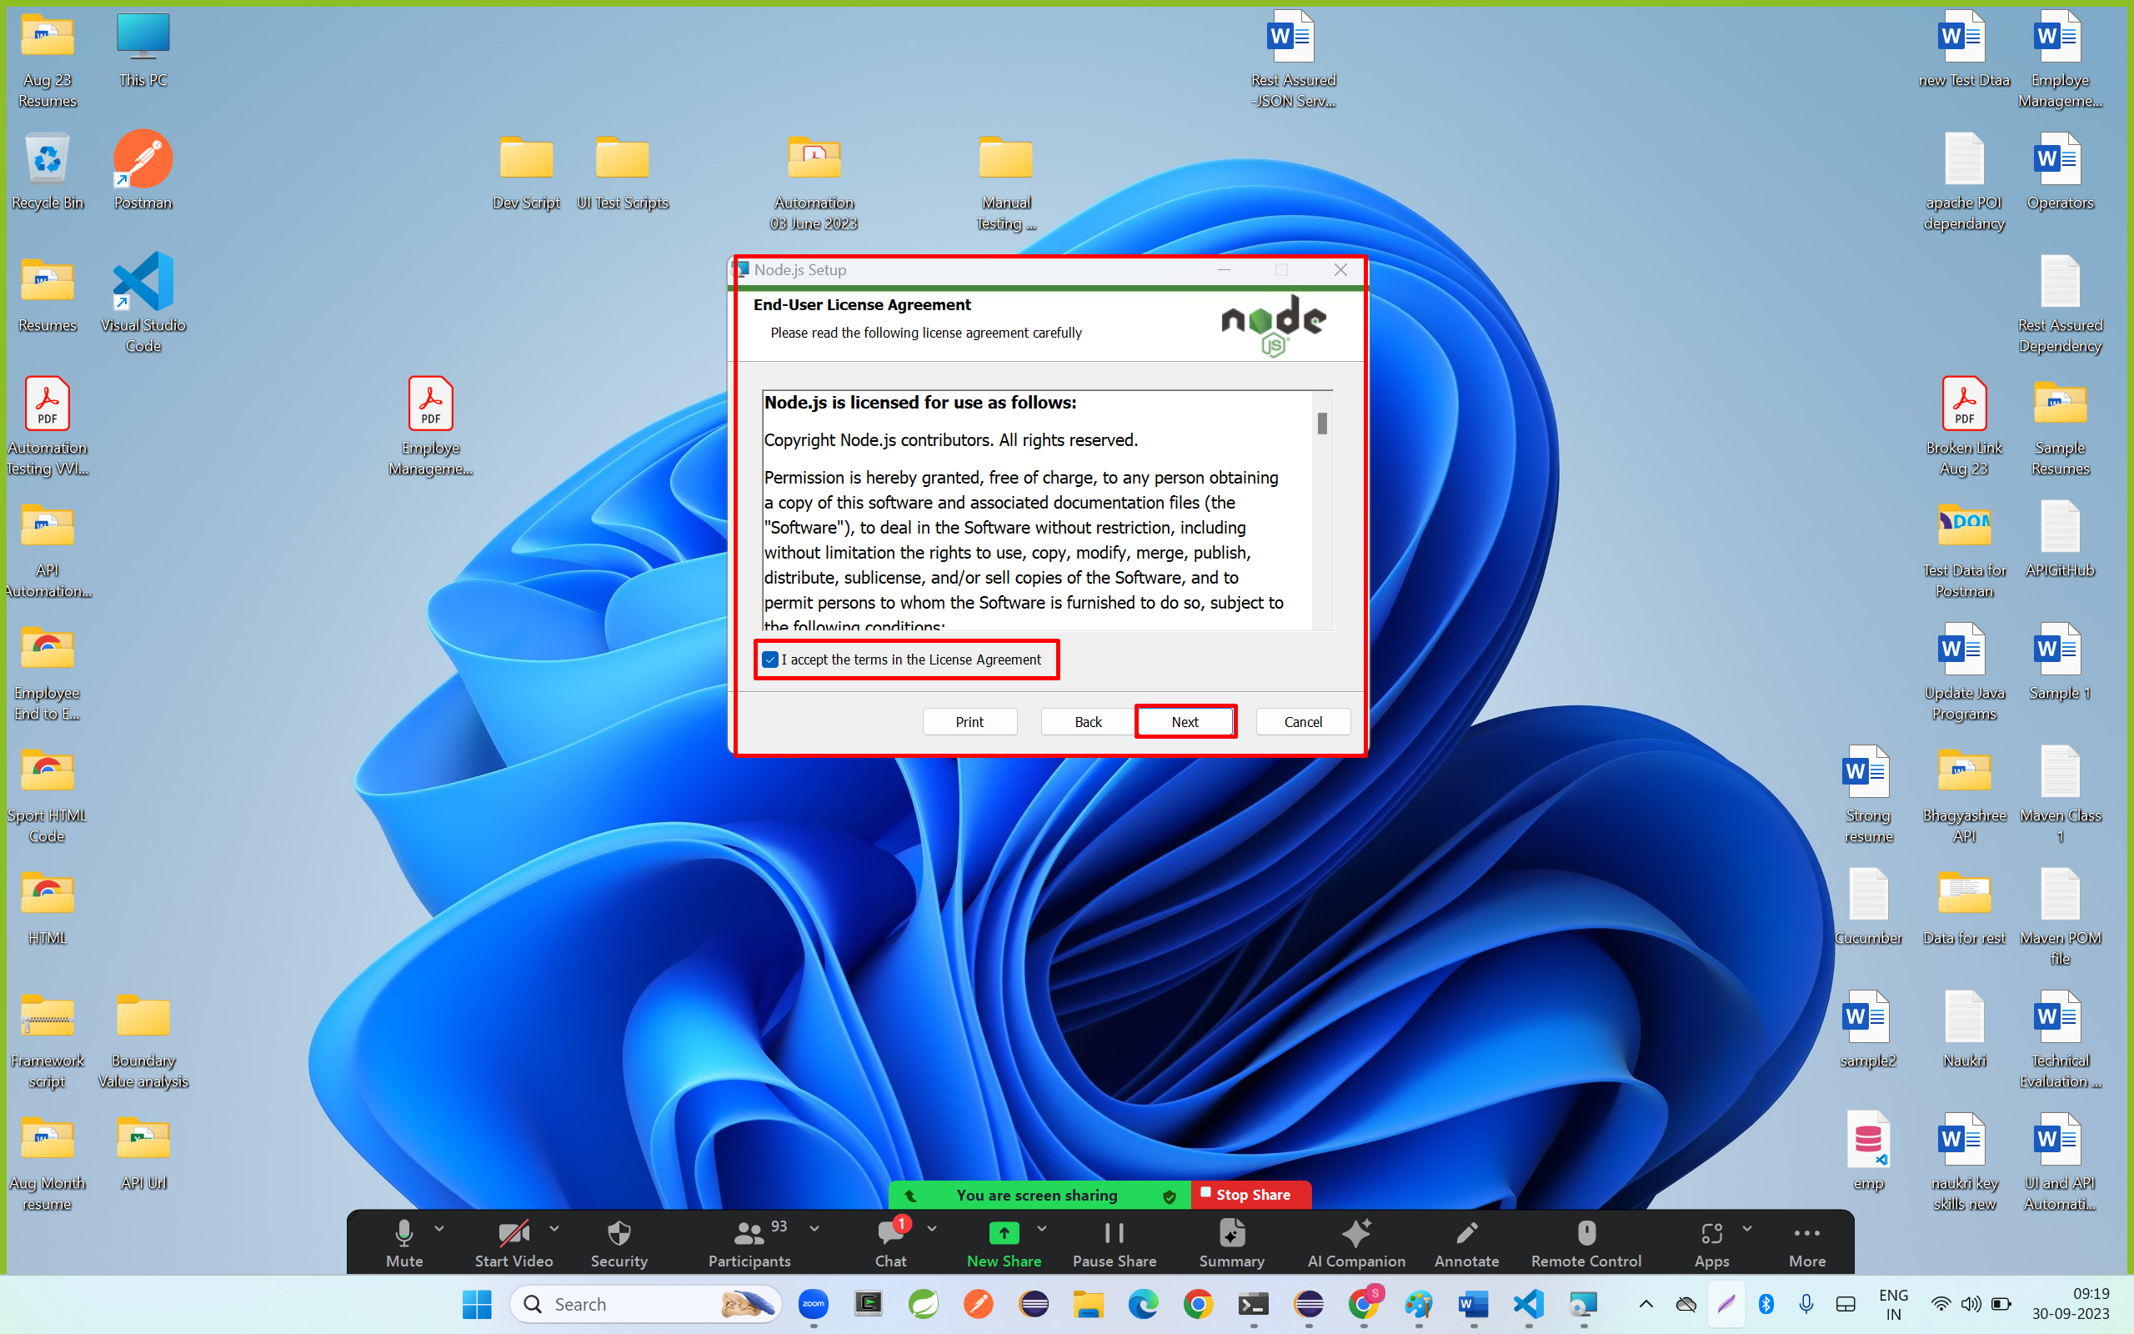

**Step 5: click on next button**

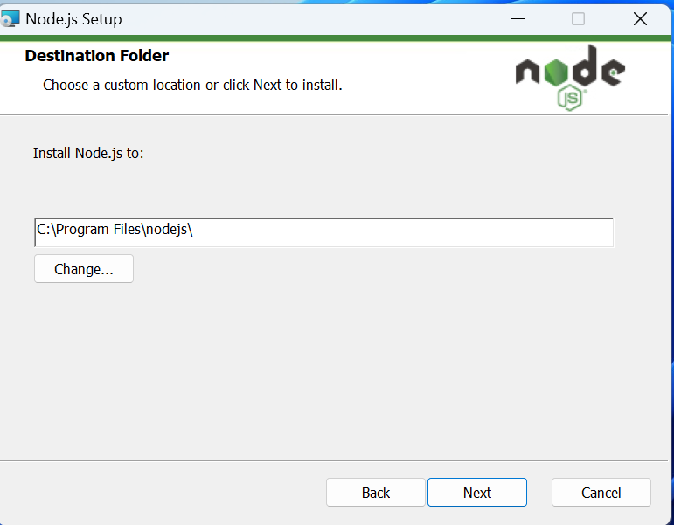

**Step 6: click on next button**

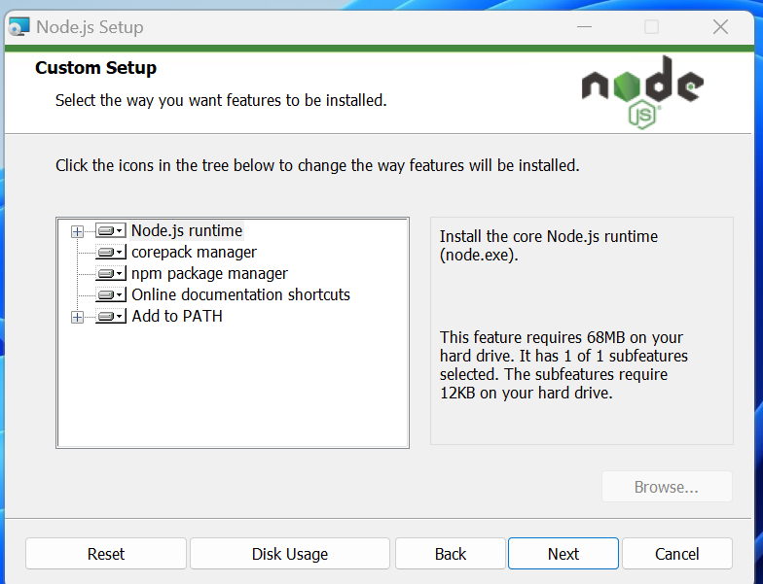

**Step 7: click on next button**

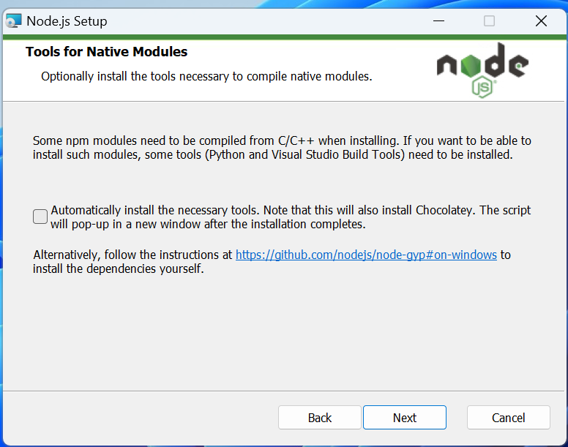

**Step 8 : click on install**

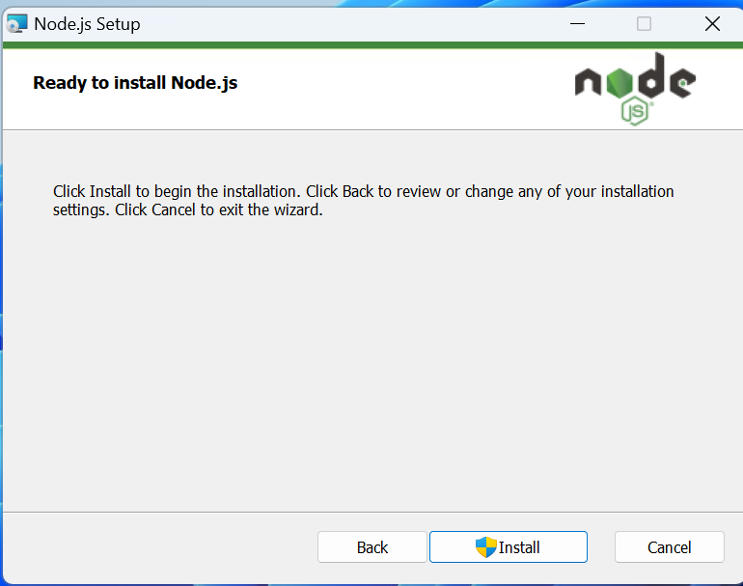

**Step 9: click on finish button**

